SYNOPSIS

The” Healthcare Beneficiary Management System” is a cutting-edge platform aimed at optimizing the management of beneficiaries within healthcare environments. By leveraging a mobile application built with React Native and a back end powered by Spring Boot, the system enhances user accessibility and operational efficiency.

The mobile app allows beneficiaries to register, update their profiles, and access health records seamlessly. This user-friendly interface ensures that individuals can manage their healthcare needs conveniently from their devices.

On the back end, Spring Boot provides a robust REST full API, handling data processing and secure interactions with a relational database. This architecture ensures reliability and Scalability, catering to varying healthcare provider needs.

Key features include appointment scheduling and automated notifications, which keep beneficiaries informed about their healthcare commitments. This proactive approach significantly enhances patient engagement and adherence to medical advice.

Additionally, an analytics dashboard empowers healthcare administrators with insights into beneficiary data and service usage. This information aids in making informed decisions to improve service delivery and patient outcomes.

Overall, the Healthcare Beneficiary Management System represents a transformative step in healthcare management, bridging the gap between technology and patient care to foster better health outcomes.

1. INTRODUCTION

1.1 About the project:

The Healthcare Beneficiary Management System is a project aimed at modernizing the management of healthcare beneficiaries through an integrated platform. Built with React Native for the mobile interface and Spring Boot java for the backend, this system provides an efficient, user-friendly solution for both patients and healthcare providers.

Project Goals:
The primary goal of the project is to streamline the processes involved in managing beneficiary information, appointments, and health records. The mobile application enables users to easily register, update personal details, and access their health data at anytime, promoting better engagement in their healthcare journey.

Technology Stack:
Using React Native allows for a cross-platform application that delivers a native-like experience on both iOS and Android devices. The Spring Boot framework supports the development of a robust RESTful API, ensuring smooth communication between the frontend and backend while maintaining high security and performance standards.

Key Features:
The system incorporates essential features such as appointment scheduling, real-time notifications, and a secure repository for health records. These functionalities enhance the user experience by providing timely reminders and easy access to critical information, which ultimately supports better health management.

Administrative Tools:
For healthcare administrators, the system includes an analytics dashboard that offers insights into beneficiary engagement and service utilization. This data-driven approach allows for informed decision-making and continuous improvement in service delivery.

Conclusion:
Overall, the Healthcare Beneficiary Management System project represents a significant advancement in the integration of technology within healthcare management. By enhancing accessibility and efficiency, it aims to improve patient outcomes and streamline operations in healthcare settings.

1.2 About the Language

Project Overview:
The system aims to streamline the registration, appointment scheduling, and health record management for beneficiaries. React Native provides a cross-platform mobile application that ensures users can access services on both iOS and Android devices, facilitating easy interaction with their healthcare information.
Technology Stack:
- React Native: This JavaScript framework allows for rapid development of mobile applications, enabling a native-like experience with smooth performance.
- Spring Boot: The backend is developed using Spring Boot, a Java-based framework that simplifies the creation of RESTful APIs, ensuring reliable and scalable server-side functionality.
- MongoDB: As a NOSQL database, MongoDB offers flexibility in data storage, accommodating various data types and structures, which is ideal for managing diverse healthcare information.

Key Features:
The system includes features such as user authentication, appointment management, and real-time notifications. Beneficiaries can easily update their profiles and receive reminders for upcoming appointments and medications, improving their overall engagement in healthcare.
Administrative Tools:
Healthcare administrators benefit from an analytics dashboard powered by the data stored in MongoDB. This feature provides insights into beneficiary usage patterns, helping to inform strategic decisions and enhance service delivery.
Conclusion:

By leveraging React Native, Spring Boot, and MongoDB, the Healthcare Beneficiary Management System offers a robust solution that modernizes healthcare management. This integration fosters better communication between beneficiaries and healthcare providers, ultimately leading to improved health outcomes and operational efficiency.

2. SYSTEM STUDY AND ANALYSIS

2.1. Existing System

In the existing system the file transactions are done only manually but in proposed system we have to computerize all the file transaction using the software File Tracking System.

2.2. Drawbacks of the Existing System

- Lack of security on File.
- More man power.
- Time consuming.
- Consumes large volume of pare work.
- Needs manual calculations.
- No direct role for the higher officials.
- Damage of machines due to lack of attention.

To avoid all these limitations and make the working more accurately the system needs to be computerized.

2.3. System Analysis

System analysis is a process of gathering and interpreting facts, diagnosing problems and the information to recommend improvements on the system. It is a problem solving activity that requires intensive communication between the system users and system developers. System analysis or study is an important phase of any system development process. The system is studied to the minutest detail and analyzed. The system analyst plays the role of the interrogator and dwells deep into the working of the present system. The system is viewed as a whole and the input to the system are identified. The outputs from the organizations are traced to the various processes. System analysis is concerned with becoming aware of the problem, identifying the relevant and decisions

variables, analyzing and synthesizing the various factors and determining an optimal or at least a satisfactory solution or program of action.

A detailed study of the process must be made by various techniques like interviews, questionnaires etc. The data collected by these sources must be scrutinized to arrive to a conclusion. The conclusion is an understanding of how the system functions. This system is called the existing system. Now the existing system is subjected to close study and problem areas are identified. The designer now functions as a problem solver and tries to sort out the difficulties that the enterprise faces. The solutions are given as proposals. The proposal is then weighed with the existing system analytically and the best one is selected. The proposal is presented to the user for an endorsement by the user. The proposal is reviewed on user request and suitable changes are made. This is loop that ends as soon as the user is satisfied with proposal.

Preliminary study is the process of gathering and interpreting facts, using the information for further studies on the system. Preliminary study is problem solving activity that requires intensive communication between the system users and system developers. It does various feasibility studies. In these studies a rough figure of the system activities can be obtained, from which the decision about the strategies to be followed for effective system study and analysis can be taken.

2.4. Proposed System

The aim of proposed system is to develop a system of improved facilities. The proposed system can overcome all the limitations of the existing system. The system provides proper security and reduces the manual work.

2. 4. 1 Advantages of the Proposed System

The system is very simple in design and to implement. The system requires very low system resources and the system will work in almost all configurations. It has got following features

- Security of data.
- Ensure data accuracy’s.
- Proper control of the higher officials.
- Reduce the damages of the machines.
- Minimize manual data entry.
- Minimum time needed for the various processing.
- Greater efficiency.
- Better service.
- User friendliness and interactive.
- Minimum time required.

2.5. Feasibility Study

Feasibility study is made to see if the project on completion will serve the purpose of the organization for the amount of work, effort and the time that spend on it. Feasibility study lets the developer foresee the future of the project and the usefulness. A feasibility study of a system proposal is according to its work-ability, which is the impact on the organization, ability to meet their user needs and effective use of resources. Thus when a new application is proposed it normally goes through a feasibility study before it is approved for development.

The document provide the feasibility of the project that is being designed and lists various areas that were considered very carefully during the feasibility study of this project such as Technical, Economic and Operational feasibility. The following are its features:

2.5.1. Technical Feasibility

The system must be evaluated from the technical point of view first. The assessment of this feasibility must be based on an outline design of the system requirement in the terms of input, output, programs and procedures. Having identified an outline system, the investigation must go on to suggest the type of equipment, required method developing the system, of running the system once it has been designed.

Technical issues raised during the investigation are:

Does the existing technology sufficient for the suggested one?
Can the system expand if developed?

The project should be developed such that the necessary functions and performance are achieved within the constraints. The project is developed within latest technology. Through the technology may become obsolete after some period of time, due to the fact that never version of same software supports older versions, the system may still be used. So there are minimal constraints involved with this project. The system has been developed using Java the project is technically feasible for development.

2.5.2. Economic Feasibility

The developing system must be justified by cost and benefit. Criteria to ensure that effort is concentrated on project, which will give best, return at the earliest. One of the factors, which affect the development of a new system, is the cost it would require.

The following are some of the important financial questions asked during preliminary investigation:

- The costs conduct a full system investigation.
- The cost of the hardware and software.
- The benefits in the form of reduced costs or fewer costly errors.

Since the system is developed as part of project work, there is no manual cost to spend for the proposed system. Also all the resources are already available, it give an indication of the system is economically possible for development.

2.5.3. Behavioral Feasibility

This includes the following questions:

  - Is there sufficient support for the users?
  - Will the proposed system cause harm?

The project would be beneficial because it satisfies the objectives when developed and installed. All behavioral aspects are considered carefully and conclude that the project is behaviorally feasible.

2.6. Hardware and Software Requirements

HARDWARE REQUIREMENTS

Processor |  | : | Intel Pentium IV
RAM |  | : | 512 MB or more
Hard disk |  | : | 20 GB or more
Monitor |  | : | VGA/SVGA
Keyboard |  | : | 104 Keys
Mouse |  | : | 2 buttons/ 3 buttons

SOFTWARE REQUIREMENTS

Operating System : Windows 10

Language : Java

Front end : React

Back end : MongoDB

3. SYSTEM DESIGN AND DEVELOPMENT PROCESS

3.1. Introduction

Design is the first step into the development phase for any engineered product or system. Design is a creative process. A good design is the key to effective system. The term “design” is defined as “the process of applying various techniques and principles for the purpose of defining a process or a system in sufficient detail to permit its physical realization”. It may be defined as a process of applying various techniques and principles for the purpose of defining a device, a process or a system in sufficient detail to permit its physical realization. Software design sits at the technical kernel of the software engineering process and is applied regardless of the development paradigm that is used. The system design develops the architectural detail required to build a system or product. As in the case of any systematic approach, this software too has undergone the best possible design phase fine tuning all efficiency, performance and accuracy levels. The design phase is a transition from a user oriented document to a document to the programmers or database personnel. System design goes through two phases of development: Logical and Physical Design.

Logical Design:

The logical flow of a system and define the boundaries of a system. It includes the following steps:
- Reviews the current physical system – its data flows, file content, volumes, frequencies etc.
- Prepares output specifications – that is, determines the format, content and frequency of reports.
- Prepares input specifications – format, content and most of the input functions.
- Prepares edit, security and control specifications.
- Specifies the implementation plan.
- Prepares a logical design walk through of the information flow, output, input, controls and implementation plan.
- Reviews benefits, costs, target dates and system constraints.

Physical Design:

Physical system produces the working systems by define the design specifications that tell the programmers exactly what the candidate system must do. It includes the following steps.
- Design the physical system.
- Specify input and output media.
- Design the database and specify backup procedures.
- Design physical information flow through the system and a physical design Walk through.
- Plan system implementation.
- Prepare a conversion schedule and target date.
- Determine training procedures, courses and timetable.
- Devise a test and implementation plan and specify any new hardware/software. • Update benefits , costs , conversion date and system constraints

Design/Specification activities:

- Concept formulation.
- Problem understanding.
- High level requirements proposals.
- Feasibility study.
- Requirements engineering.
- Architectural design.

3.2. Input Design

The design of input focuses on controlling the amount of input required, controlling the errors, avoiding delay, avoiding extra steps and keeping the process simple. The input is designed in such a way so that it provides security and ease of use with retaining the privacy. Input Design considered the following things:

- What data should be given as input?
- How the data should be arranged or coded?
- The dialog to guide the operating personnel in providing input.
- Methods for preparing input validations and steps to follow when error occur.

Objectives

Input Design is the process of converting a user-oriented description of the input into a computer-based system. This design is important to avoid errors in the data input process and show the correct direction to the management for getting correct information from the computerized system.
It is achieved by creating user-friendly screens for the data entry to handle large volume of data. The goal of designing input is to make data entry easier and to be free from errors. The data entry screen is designed in such a way that all the data manipulates can be performed. It also provides record viewing facilities.
When the data is entered it will check for its validity. Data can be entered with the help of screens. Appropriate messages are provided as when needed so that the user will not be in a maze of instant. Thus the objective of input design is to create an input layout that is easy to follow

3.3. Output design

A quality output is one, which meets the requirements of the end user and presents the information clearly. In output design it is determined how the information is to be displaced for immediate need and also the hard copy output. It is the most important and direct source information to the user. Efficient and intelligent output design improves the system’s relationship to help user decision-making.

Designing computer output should proceed in an organized, well thought out manner; the right output must be developed while ensuring that each output element is designed so that people will find the system can use easily and effectively. When analysis design computer output, they should:

- Identify the specific output that is needed to meet the requirements.
- Select methods for presenting information.
- Create document, report, or other formats that contain information produced by the system.

3.4. Database design

MongoDB Design Concept

Overview:

MongoDB is a No-SQL database designed for Availability, flexibility, and performance. It stores data in a J SON-like format (BSON), allowing for a schema-less structure. This design concept emphasizes how to effectively model data in MongoDB to leverage its strengths, accommodate diverse data types, and optimize performance.

Data Modeling

1. Schema Design

MongoDB allows for dynamic schema, which means you can store documents with varying structures. This flexibility is useful for applications that evolve over time. However, planning a schema is crucial for data integrity and performance.

Embedded Documents: Use embedded documents for related data that is frequently accessed together. For example, a user profile might include an embedded array of addresses:

j son
{
"username": "Joe",
"email": "joe12@example.com",
"addresses": [
{
"type": "home",
"street": "123 Main St",
"city": "Any-town"
},
{
"type": "work",
"street": "456 Corporate Blvd",
"city": "Business City"
}
]
}
```

References: Use references for data that is large or rarely accessed together. For instance, in a blog application, you might store posts and comments in separate collections:

`j son
// Post Document
{
"title": "My First Post",
"content": "Hello World!",
"comments": [
Object Id("comment_id_1"),
Object Id("comment_id_2")
]
}
```

2. Collections and Indexing

Collections in MongoDB are analogous to tables in relational databases. It's essential to organize data into collections based on how it will be accessed. Indexing is crucial for optimizing query performance.

Index Types

- Single Field Index: Improves performance on queries using one field.
- Compound Index: Supports queries on multiple fields, useful for sorting and filtering.
- Text Index: Facilitates text search capabilities.

Performance Optimization

1. Query Optimization

MongoDB 's query language allows for complex queries. Use the aggregation framework for data processing, transforming, and computing results efficiently. Always analyze query performance using the `explain` method.

2. Sharding

For large-scale applications, sharding distributes data across multiple servers, allowing for horizontal scaling. Choose an appropriate shard key that evenly distributes data to avoid hotpots.

Data Integrity and Transactions

While MongoDB is designed for high availability and scalability, it also supports multi-document ACID transactions, enabling operations across multiple documents and collections to be executed reliably. Use transactions when data consistency across collections is essential.

Conclusion

MongoDB 's flexible schema, powerful indexing, and scalability features make it an ideal choice for modern applications. Properly designing your data model, optimizing performance, and ensuring data integrity will enable you to harness the full potential of MongoDB, leading to robust and scalable applications.

3.5. Table Design

Table: Beneficiary
Primary Key : admin_ID

Field | Data Type | Constraints | Description
Id | Int(10) | Primary key
Beneficiary Name | Varchar(120) |  | Name
Beneficiary Mobile | Int(200) |  | Mobile no
Medical history | Varchar(200) |  | Medical history

Table : Sign Up
Primary Key: ID

Field | Data Type | Constraints | Description
Id | Int(10) | Primary key
Firs name | Varchar(250) |  | Admin name
Last name | Varchar(250) |  | Admin_last name
Mobile number | Big int(10) |  | Admin_mobile no
Password | Medium text |  | Admin password

Table: Personal Details
Primary Key: id

Field | Data Type | Constraints | Description
Id | Int(10) | Primary_key
First name | Varchar(200) |  | Customer first name
Last name | Varchar(150) |  | Customer Last name
Email | Varchar(200) |  | Customer email
Mobile number | Big int(10) |  | Customer mobile number
Gender | Medium text |  | Customer gender
Dob | Int(10) |  | Customer dob
Address line1 | Varchar(200) |  | Customer address
Address line2 | Varchar(200) |  | customer address
Country | timestamp |  | Customer country
State | Varchar(200) |  | Customer state
City | Varchar(200) |  | Customer city
Zip code | Medium text |  | Customer code

3.6. Data Flow Diagram:

A Data Flow Diagram (DFD) is a traditional visual representation of the information flows within a system. A neat and clear DFD can depict the right amount of the system requirement graphically. It can be manual, automated, or a combination of both.
It shows how data enters and leaves the system, what changes the information, and where data is stored.
The objective of a DFD is to show the scope and boundaries of a system as a whole. It may be used as a communication tool between a system analyst and any person who plays a part in the order that acts as a starting point for redesigning a system. The DFD is also called as a data flow graph or bubble chart.

Level 0:

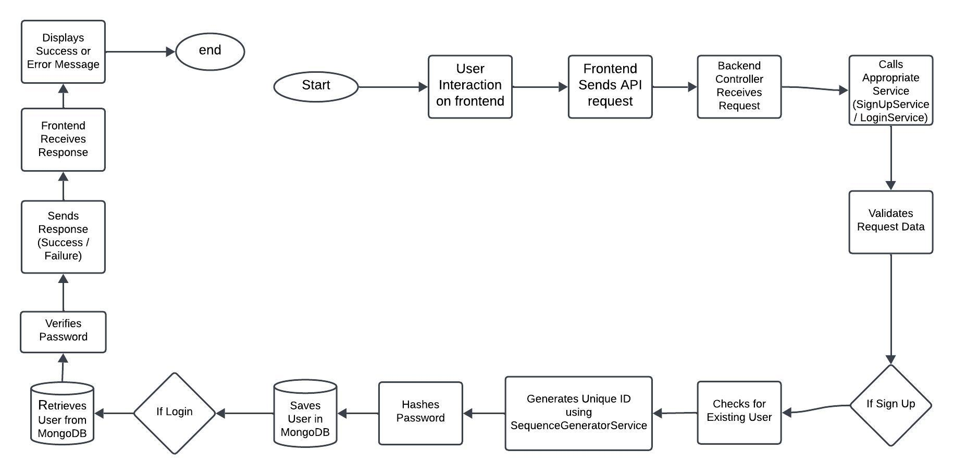

Level 1:

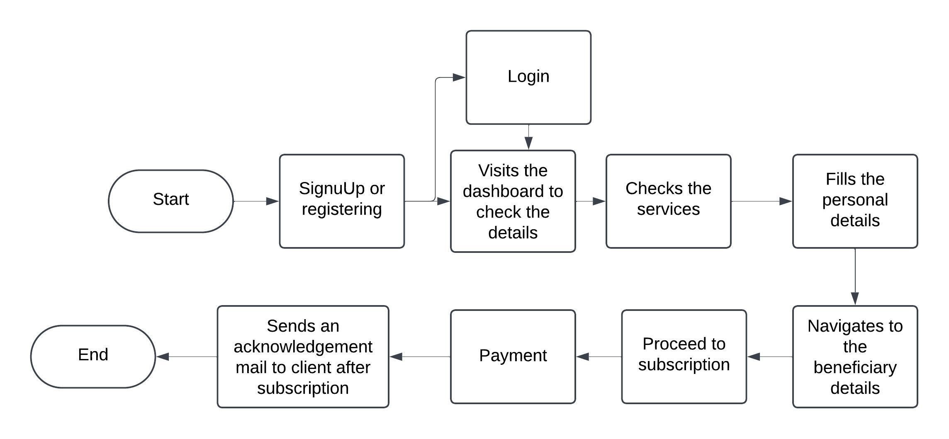

3.7 ER Diagram:
E-R (Entity-Relationship) Diagram is used to represents the relationship between
entities in the table.

User
├── User Id(Primary Key)
├── Email
├── Password
├── First Name
├── Last Name
├── Mobile Number
└─ Confirm Password

Profile
├── Profile Id (Primary Key)
├── User ID ( Foreign Key)
├── Date Of Birth
├── Gender
├── Address
├── Country
├── State
├── City
├── Zip Code
└── [Belongs to] → User

Beneficiary
├── Beneficiary ID (PK)
├── Beneficiary Name
├── medical history
├──Insurance name
└── phone number

Subscription
├── Subscripton ID (PK)
├── User ID (Foreign Key)
├── Beneficiary ID (Foreign key)
├── Payment Date
├── Payment Status
├── Package Amount
└── [Belongs to] → User, [Is for] → Service

Admin
├── Admin ID (PK)
├── User ID (FK)
├── Permissions
└── [Is a] → User

4. SYSTEM TESTING AND IMPLEMENTATION

4.1. System Testing

Software Testing is the process of executing software in a controlled manner, in order to answer the question - Does the software behave as specified?. Software testing is often used in association with the terms verification and validation. Validation is the checking or testing of items, includes software, for conformance and consistency with an associated specification. Software testing is just one kind of verification, which also uses techniques such as reviews, analysis, inspections, and breakthroughs. Validation is the process of checking that what has been specified is what the user actually wanted.

Validation : Are we doing the right job? Verification : Are we doing the job right?

Software testing should not be confused with debugging. Debugging is the process of analyzing and localizing bugs when software does not behave as expected. Although the identification of some bugs will be obvious from playing with the software, a methodical approach to software testing is a much more thorough means for identifying bugs. Debugging is therefore an activity which supports testing, but cannot replace testing.

Other activities which are often associated with software testing are static analysis and dynamic analysis. Static analysis investigates the source code of software, looking for problems and gathering metrics without actually executing the code. Dynamic analysis looks at the behavior of software while it is executing, to provide information such as execution traces, timing profiles, and test coverage information.

Testing is a set of activity that can be planned in advanced and conducted systematically. Testing begins at the module level and work towards the integration of entire computers based system. Nothing is complete without testing, as it vital success of the system testing objectives, there are several rules that can serve as testing objectives.

Testing is a process of executing a program with the intend of finding an error.A good test case is one that has high possibility of finding an undiscovered error.A successful test is one that uncovers an undiscovered error.

If a testing is conducted successfully according to the objectives as stated above, it would uncovered errors in the software also testing demonstrate that the software function appear to be working according to the specification, that performance requirement appear to have been met.

There are three ways to test program.
- For correctness
- For implementation efficiency
- For computational complexity

Test for correctness are supposed to verify that a program does exactly what it was designed to do. This is much more difficult than it may at first appear, especially for large programs.

Test Plan

A test plan implies a series of desired course of action to be followed in accomplishing various testing methods. The Test Plan acts as a blue print for the action that is to be followed. The software engineers create a computer program, its documentation and related data structures. The software developers is always responsible for testing the individual units of the programs, ensuring that each performs the function for which it was designed. There is an independent test group (ITG) which is to remove the inherent problems associated with letting the builder to test the thing that has been built.

The specific objectives of testing should be stated in measurable terms. So that the mean time to failure, the cost to find and fix the defects, remaining defect density or frequency of occurrence and test work-hours per regression test all should be stated within the test plan.

The levels of testing include:

- Unit testing
- Integration Testing
- Data validation Testing
- Output Testing

4.1.1. Unit Testing

Unit testing focuses verification effort on the smallest unit of software design – the software component or module. Using the component level design description as a guide, important control paths are tested to uncover errors within the boundary of the module. The relative complexity of tests and uncovered scope established for unit testing. The unit testing is white-box oriented, and step can be conducted in parallel for multiple components. The modular interface is tested to ensure that information properly flows into and out of the program unit under test. The local data structure is examined to ensure that data stored temporarily maintains its integrity during all steps in an algorithm’s execution. Boundary conditions are tested to ensure that all statements in a module have been executed at least once. Finally, all error handling paths are tested.

Tests of data flow across a module interface are required before any other test is initiated. If data do not enter and exit properly, all other tests are moot. Selective testing of execution paths is an essential task during the unit test. Good design dictates that error conditions be anticipated and error handling paths set up to reroute or cleanly terminate processing when an error does occur. Boundary testing is the last task of unit testing step.
Software often fails at its boundaries.

Unit testing was done in Sell-Soft System by treating each module as separate entity and testing each one of them with a wide spectrum of test inputs. Some flaws in the internal logic of the modules were found and were rectified.

4.1.2. Integration Testing

Integration testing is systematic technique for constructing the program structure while at the same time conducting tests to uncover errors associated with interfacing. The objective is to take unit tested components and build a program structure that has been dictated by design. The entire program is tested as whole. Correction is difficult because isolation of causes is complicated by vast expanse of entire program. Once these errors are corrected, new ones appear and the process continues in a seemingly endless loop.

After unit testing in Sell-Soft System all the modules were integrated to test for any inconsistencies in the interfaces. Moreover differences in program structures were removed and a unique program structure was evolved.

4.1.3. Validation Testing or System Testing

This is the final step in testing. In this the entire system was tested as a whole with all forms, code, modules and class modules. This form of testing is popularly known as Black Box testing or System testing.

Black Box testing method focuses on the functional requirements of the software. That is, Black Box testing enables the software engineer to derive sets of input conditions that will fully exercise all functional requirements for a program.

Black Box testing attempts to find errors in the following categories; incorrect or missing functions, interface errors, errors in data structures or external data access, performance errors and initialization errors and termination errors.

4.1.4. Output Testing or User Acceptance Testing

The system considered is tested for user acceptance; here it should satisfy the firm’s need. The software should keep in touch with perspective system; user at the time of developing and making changes whenever required. This done with respect to the following points

- Input Screen Designs,
- Output Screen Designs,
- Online message to guide the user and the like.

The above testing is done taking various kinds of test data. Preparation of test data plays a vital role in the system testing. After preparing the test data, the system under study is tested using that test data. While testing the system by which test data errors are again uncovered and corrected by using above testing steps and corrections are also noted for future use.

4.2. System Implementation:

Implementation is the stage of the project where the theoretical design is turned into a working system. It can be considered to be the most crucial stage in achieving a successful new system gaining the users confidence that the new system will work and will be effective and accurate. It is primarily concerned with user training and documentation. Conversion usually takes place about the same time the user is being trained or later. Implementation simply means convening a new system design into operation, which is the process of converting a new revised system design into an operational one.

Implementation is the state in the project where the theoretical design is turned into a working system. By this, the users get the confidence that the system will work effectively. The system can be implemented only after through testing.

4.3. Training

Once the system is successfully developed the next important step is to ensure that the administrators are well trained to handle the system. This is because the success of a system invariably depends on how they are operated and used. The implementation depends upon the right people being at the right place at the right time. Education involves creating the right atmosphere and motivating the user. The administrators are familiarized with the run procedures of the system, working through the sequence of activities on an ongoing basis.

The systems personnel check the feasibility of the system. The actual data were inputted to the system and the working of the system was closely monitored. The master option was selected from the main menu and the actual data were input through the corresponding input screens. The data movement was studied and found to be correct queries option was then selected and this contains various reports. Utilities provide various data needed for inventory was input and the module was test run. Satisfactory results were obtained. Reports related to these processes were also successfully generated. Various input screen formats are listed in the appendix.

4.4. System Maintenance:

The Last part of the system development lifecycle is the System maintenance, which is actually the implementation of the post implementation review planned. Maintenance means resorting to its original position. The Proposed System has been designed with effective tools and techniques. The System was designed such that the future changes can be made with minimum changes in the code. The system was also designed to be flexible and Adaptable, so that the maintenance cost in the future can be reduced as much as possible. It has been made easier to maintain the database. Only the authorized person of the institution has been allowed to access the database.

5. APPENDIX

5.1. Sample Source Code:

AddBeneficiaryScreen:

import React, { useState } from 'react';
import { View, TextInput, Button, StyleSheet, ImageBackground, ScrollView, Dimensions } from 'react-native';
import { useNavigation } from '@react-navigation/native';
import { StackNavigationProp } from '@react-navigation/stack';

// Define the types for the navigation and route parameters
type RootStackParamList = {
BeneficiaryDetailsScreen: { newBeneficiary: Beneficiary; isEditing: boolean };
AddBeneficiaryScreen: { beneficiary?: Beneficiary; isEditing: boolean } | undefined;
};

type NavigationProp = StackNavigationProp<RootStackParamList, 'AddBeneficiaryScreen'>;

// Define the Beneficiary type
interface Beneficiary {
id: string;
name: string;
mobile: string;
history: string;
email: string;
gender: string;
dob: string;
address1: string;
address2: string;
country: string;
state: string;
city: string;
zip: string;
}

const { width, height } = Dimensions.get('window'); // Get screen dimensions for responsiveness

const AddBeneficiaryScreen: React.FC = () => {
const navigation = useNavigation<NavigationProp>(); // Correct way to use navigation

const [name, setName] = useState<string>('');
const [mobile, setMobile] = useState<string>('');
const [history, setHistory] = useState<string>('');
const [email, setEmail] = useState<string>('');
const [gender, setGender] = useState<string>('');
const [dob, setDob] = useState<string>('');
const [address1, setAddress1] = useState<string>('');
const [address2, setAddress2] = useState<string>('');
const [country, setCountry] = useState<string>('');
const [state, setState] = useState<string>('');
const [city, setCity] = useState<string>('');
const [zip, setZip] = useState<string>('');

// Handle Save or Update
const handleSave = () => {
const newBeneficiary: Beneficiary = {
id: Date.now().toString(), // Assign a unique id
name,
mobile,
history,
email,
gender,
dob,
address1,
address2,
country,
state,
city,
zip,
};

// Navigate back with the new beneficiary data
navigation.navigate('BeneficiaryDetailsScreen', { newBeneficiary, isEditing: false });
};

return (
<ImageBackground
source={require('../../assets/images/healthcare-image.png')} // Ensure the correct path to your image
style={styles.background}
blurRadius={5} // Apply blur to the background image
resizeMode="cover" // To make sure the image covers the entire screen
>
<ScrollView contentContainerStyle={styles.scrollContainer}>
<View style={styles.formContainer}>
<TextInput style={styles.input} placeholder="Beneficiary Name" value={name} onChangeText={setName} />
<TextInput style={styles.input} placeholder="Beneficiary Mobile" value={mobile} onChangeText={setMobile} keyboardType="phone-pad" />
<TextInput style={styles.input} placeholder="Medical History" value={history} onChangeText={setHistory} />
<TextInput style={styles.input} placeholder="Email Address" value={email} onChangeText={setEmail} keyboardType="email-address" />
<TextInput style={styles.input} placeholder="Gender" value={gender} onChangeText={setGender} />
<TextInput style={styles.input} placeholder="Date of Birth" value={dob} onChangeText={setDob} />
<TextInput style={styles.input} placeholder="Temporary Address" value={address1} onChangeText={setAddress1} />
<TextInput style={styles.input} placeholder="Permanent Address" value={address2} onChangeText={setAddress2} />
<TextInput style={styles.input} placeholder="Country" value={country} onChangeText={setCountry} />
<TextInput style={styles.input} placeholder="State" value={state} onChangeText={setState} />
<TextInput style={styles.input} placeholder="City" value={city} onChangeText={setCity} />
<TextInput style={styles.input} placeholder="Zip Code" value={zip} onChangeText={setZip} keyboardType="number-pad" />
<Button title="Save Beneficiary" onPress={handleSave} />
</View>
</ScrollView>
</ImageBackground>
);
};

const styles = StyleSheet.create({
background: {
width: width,
height: height,
flex: 1,
},
scrollContainer: {
paddingVertical: 20,
flexGrow: 1,
justifyContent: 'center',
},
formContainer: {
flex: 1,
paddingHorizontal: 20,
alignItems: 'center', // Center align the input fields
},
input: {
height: 40,
width: '30%', // Adjust the width of each input field to make it look nicer
borderColor: 'gray',
borderWidth: 1,
marginBottom: 10,
paddingHorizontal: 10,
backgroundColor: '#fff', // Make inputs more readable
borderRadius: 5,
},
});

export default AddBeneficiaryScreen;

AppFooter:

import React from 'react';
import { TouchableOpacity, StyleSheet, Text, View } from 'react-native';
import { useNavigation, NavigationProp } from '@react-navigation/native';
import { MaterialIcons } from '@expo/vector-icons'; // Updated import

// Define the navigation type for your root stack
type RootStackParamList = {
PackageDetailsScreen: undefined;
BeneficiaryDetailsScreen: undefined;
ContactUsScreen: undefined;
};

const AppFooter: React.FC = () => {
// Specify the type for the navigation prop
const navigation = useNavigation<NavigationProp<RootStackParamList>>();

return (
<View style={styles.footer}>
{/* Package Details Button */}
<TouchableOpacity style={styles.iconButton} onPress={() => navigation.navigate('PackageDetailsScreen')}>
<MaterialIcons name="local-shipping" size={24} color="black" />
<Text style={styles.footerText}>Package Details</Text>
</TouchableOpacity>

{/* Beneficiary Details Button */}
<TouchableOpacity style={styles.iconButton} onPress={() => navigation.navigate('BeneficiaryDetailsScreen')}>
<MaterialIcons name="account-circle" size={24} color="black" />
<Text style={styles.footerText}>Beneficiary Details</Text>
</TouchableOpacity>

{/* Contact Us Button */}
<TouchableOpacity style={styles.iconButton} onPress={() => navigation.navigate('ContactUsScreen')}>
<MaterialIcons name="phone" size={24} color="black" />
<Text style={styles.footerText}>Contact Us</Text>
</TouchableOpacity>
</View>
);
};

const styles = StyleSheet.create({
footer: {
flexDirection: 'row',
justifyContent: 'space-around',
paddingVertical: 10,
borderTopWidth: 1,
borderColor: '#ccc',
backgroundColor: '#f9f9f9',
},
iconButton: {
alignItems: 'center', // Align icons and text
},
footerText: {
fontSize: 12,
textAlign: 'center',
marginTop: 4, // Spacing between icon and text
},
});

export default AppFooter;

WelcomeScree:

import React, { useEffect, useRef } from 'react';
import { StyleSheet, View, Text, Image, Animated } from 'react-native';
import { useNavigation } from '@react-navigation/native';
import { StackNavigationProp } from '@react-navigation/stack';

// Define the navigation type for your stack
type RootStackParamList = {
LoginScreen: undefined;
};

type WelcomeScreenNavigationProp = StackNavigationProp<RootStackParamList, 'LoginScreen'>;

const WelcomeScreen: React.FC = () => {
const navigation = useNavigation<WelcomeScreenNavigationProp>();

// Animated values for opacity and color
const opacity = useRef(new Animated.Value(0)).current;
const color = useRef(new Animated.Value(0)).current;

// Automatically navigate to the LoginScreen after 5 seconds
useEffect(() => {
const timer = setTimeout(() => {
navigation.navigate('LoginScreen');
}, 5000); // 5 seconds delay

// Start the animation when the component is mounted
Animated.sequence([
Animated.timing(opacity, {
toValue: 1,
duration: 2000,
useNativeDriver: true,
}),
Animated.timing(color, {
toValue: 1,
duration: 3000,
useNativeDriver: false,
})
]).start();

return () => clearTimeout(timer);
}, [navigation]);

// Interpolated color value (from black to blue)
const interpolatedColor = color.interpolate({
inputRange: [0, 1],
outputRange: ['#000', '#007BFF'], // Black to Blue
});

return (
<View style={styles.container}>
{/* Logo */}
<Image source={require('./Welcome.jpg')} style={styles.logo} />

{/* Animated content */}
<Animated.Text style={[styles.content, { opacity }]}>WeStayClose</Animated.Text>
<Animated.Text style={[styles.description, { color: interpolatedColor }]}>
Care for Your Loved Ones, Wherever You Are
</Animated.Text>
</View>
);
};

const styles = StyleSheet.create({
container: {
flex: 1,
justifyContent: 'center',
alignItems: 'center',
backgroundColor: '#e8fffb',
},
logo: {
width: 200,
height: 200, // Adjust logo size as needed
marginBottom: 20,
},
content: {
fontSize: 32, // Make the font size larger
fontWeight: 'bold',
marginBottom: 10,
color: '#000', // Start with black, will animate to blue
},
description: {
fontSize: 16,
textAlign: 'center',
paddingHorizontal: 20,
marginBottom: 30,
},
});

export default WelcomeScreen;

LoginScreen:

import React, { memo, useState } from 'react';
import { TouchableOpacity, StyleSheet, Text, View, Image, Animated, ImageBackground, Dimensions } from 'react-native';
import { useNavigation } from '@react-navigation/native';
import { StackNavigationProp } from '@react-navigation/stack';
import Header from '../components/Header';
import TextInput from '../components/TextInput';

// Define the navigation type for your stack
type RootStackParamList = {
ForgotPasswordScreen: undefined;
SignUpScreen: undefined;
DashboardScreen: undefined;
};

// Define the navigation prop type using StackNavigationProp
type LoginScreenNavigationProp = StackNavigationProp<RootStackParamList, 'ForgotPasswordScreen'>;

const { width, height } = Dimensions.get('window'); // Get screen width and height

const LoginScreen: React.FC = () => {
const [email, setEmail] = useState<{ value: string; error: string }>({ value: '', error: '' });
const [password, setPassword] = useState<{ value: string; error: string }>({ value: '', error: '' });
const [scaleValue] = useState(new Animated.Value(1)); // For button scale animation

const navigation = useNavigation<LoginScreenNavigationProp>();

const handleLogin = () => {
if (!email.value) {
setEmail({ ...email, error: 'Email is required.' });
return;
}
if (!password.value) {
setPassword({ ...password, error: 'Password is required.' });
return;
}
navigation.navigate('DashboardScreen');
};

const handlePressIn = () => {
Animated.spring(scaleValue, {
toValue: 0.96,
useNativeDriver: true,
}).start();
};

const handlePressOut = () => {
Animated.spring(scaleValue, {
toValue: 1,
useNativeDriver: true,
}).start();
};

return (
<ImageBackground
source={require('../../assets/images/healthcare-background.png')} // Ensure the correct path to your image
style={styles.background}
imageStyle={{ resizeMode: 'cover', width: '100%', height: '100%' }} // Ensure the image covers the full screen
>
<View style={styles.overlay}> {/* Add a subtle overlay for better visibility */}
<View style={styles.container}>
<Image source={require('./Logo.jpg')} style={styles.logo} />
<Header>Sign Into Your Account</Header>

<TextInput
label="Email Address"
placeholder="Email Address"
returnKeyType="next"
value={email.value}
onChangeText={(text: string) => setEmail({ value: text, error: '' })}
errorText={email.error}
autoCapitalize="none"
autoComplete="email"
textContentType="emailAddress"
keyboardType="email-address"
style={styles.input}
/>

<TextInput
label="Password"
placeholder="Password"
returnKeyType="done"
value={password.value}
onChangeText={(text: string) => setPassword({ value: text, error: '' })}
errorText={password.error}
secureTextEntry
style={styles.input}
/>

<View style={styles.forgotPassword}>
<TouchableOpacity onPress={() => navigation.navigate('ForgotPasswordScreen')}>
<Text style={styles.link}>Forgot Password?</Text>
</TouchableOpacity>
</View>

<Animated.View style={{ transform: [{ scale: scaleValue }] }}>
<TouchableOpacity
style={styles.button}
onPress={handleLogin}
onPressIn={handlePressIn}
onPressOut={handlePressOut}
>
<Text style={styles.buttonText}>Login</Text>
</TouchableOpacity>
</Animated.View>

{/* Move the sign-up link closer to the button */}
<View style={styles.row}>
<Text>Don’t have an account? </Text>
<TouchableOpacity onPress={() => navigation.navigate('SignUpScreen')}>
<Text style={styles.link}>Sign Up</Text>
</TouchableOpacity>
</View>
</View>
</View>
</ImageBackground>
);
};

const styles = StyleSheet.create({
background: {
width: width, // Set the width to the full screen width
height: height, // Set the height to the full screen height
flex: 1, // Ensure the background takes up the full screen
},
overlay: {
flex: 1,
backgroundColor: 'rgba(255, 255, 255, 0.8)', // Add a semi-transparent white overlay for clarity
justifyContent: 'center',
alignItems: 'center',
},
container: {
width: '100%',
padding: 16,
justifyContent: 'center',
alignItems: 'center',
marginTop: -80, // Move the form upwards
},
logo: {
width: 150,
height: 150,
marginBottom: 20,
marginTop: 60, // Adjusted this to bring the logo downwards
},
input: {
width: '100%',
padding: 10,
backgroundColor: '#e8fffb', // Add background color to input fields for clarity
borderRadius: 10,
marginBottom: 15,
fontSize: 16,
},
forgotPassword: {
marginTop: 10, // Add space between the password field and the forgot password link
alignItems: 'center',
},
row: {
flexDirection: 'row',
marginTop: 20, // Adjusted margin for better spacing above the "Sign Up" link
alignItems: 'center',
justifyContent: 'center',
},
link: {
fontWeight: 'bold',
color: '#007AFF',
},
button: {
width: 200,
height: 50,
backgroundColor: '#FFAB9D',
borderRadius: 28,
justifyContent: 'center',
alignItems: 'center',
marginTop: 15, // Add space between the forgot password and the login button
},
buttonText: {
fontSize: 16,
fontWeight: '900',
color: '#111',
textTransform: 'uppercase',
},
});

export default memo(LoginScreen);

DashboardScreen:

import React, { useState } from 'react';
import { View, Text, TouchableOpacity, StyleSheet, Animated, ImageBackground } from 'react-native';
import { useNavigation } from '@react-navigation/native';
import AppHeader from './AppHeader';
import AppFooter from './AppFooter';

const DashboardScreen: React.FC = () => {
const navigation = useNavigation();
const [scaleValue] = useState(new Animated.Value(1));

// Simulating button hover effect
const handlePressIn = () => {
Animated.spring(scaleValue, {
toValue: 0.96,
useNativeDriver: true,
}).start();
};

const handlePressOut = () => {
Animated.spring(scaleValue, {
toValue: 1,
useNativeDriver: true,
}).start();
};

return (
<ImageBackground
source={require('../../assets/images/dashboard-background.gif')}
style={styles.background}
resizeMode="cover"
>
<View style={styles.container}>
<AppHeader username="John Doe" lastLogin="10/18/2024" />

<View style={styles.content}>
<Animated.View style={[styles.buttonContainer, { transform: [{ scale: scaleValue }] }]}>
<TouchableOpacity
style={styles.button}
onPressIn={handlePressIn}
onPressOut={handlePressOut}
onPress={() => navigation.navigate('PersonalDetailsScreen')}
>
<Text style={styles.buttonText}>Personal Details</Text>
</TouchableOpacity>
</Animated.View>

<Animated.View style={[styles.buttonContainer, { transform: [{ scale: scaleValue }] }]}>
<TouchableOpacity
style={styles.button}
onPressIn={handlePressIn}
onPressOut={handlePressOut}
onPress={() => navigation.navigate('BeneficiaryDetailsScreen')}
>
<Text style={styles.buttonText}>Beneficiary Details</Text>
</TouchableOpacity>
</Animated.View>

<Animated.View style={[styles.buttonContainer, { transform: [{ scale: scaleValue }] }]}>
<TouchableOpacity
style={styles.button}
onPressIn={handlePressIn}
onPressOut={handlePressOut}
onPress={() => navigation.navigate('PackageDetailsScreen')}
>
<Text style={styles.buttonText}>Package Details</Text>
</TouchableOpacity>
</Animated.View>

<Animated.View style={[styles.buttonContainer, { transform: [{ scale: scaleValue }] }]}>
<TouchableOpacity
style={styles.button}
onPressIn={handlePressIn}
onPressOut={handlePressOut}
onPress={() => navigation.navigate('SubscriptionScreen')}
>
<Text style={styles.buttonText}>Subscription</Text>
</TouchableOpacity>
</Animated.View>
</View>

<AppFooter />
</View>
</ImageBackground>
);
};

const styles = StyleSheet.create({
background: {
flex: 1,
width: '100%',
height: '100%',
},
container: {
flex: 1,
justifyContent: 'space-between',
paddingHorizontal: 20,
},
content: {
flex: 1,
justifyContent: 'center',
alignItems: 'center',
},
buttonContainer: {
marginBottom: 20, // Space between buttons
},
button: {
width: 250,
height: 60,
backgroundColor: '#85afe7',
borderRadius: 30,
justifyContent: 'center',
alignItems: 'center',
shadowColor: '#000',
shadowOffset: { width: 0, height: 4 },
shadowOpacity: 0.3,
shadowRadius: 4.65,
elevation: 8,
},
buttonText: {
color: '#fff',
fontSize: 18,
fontWeight: 'bold',
},
});

export default DashboardScreen;

PackageDetailsScreen:

import React from 'react';
import { View, Text, StyleSheet, ImageBackground } from 'react-native';

const PackageDetailsScreen = () => {
return (
<ImageBackground
source={require('../../assets/images/healthcare-package-background.jpg')} // Ensure the image path is correct
style={styles.background}
blurRadius={5} // Apply blur to the background image
resizeMode="cover" // Ensures the image covers the full screen
>
<View style={styles.container}>
<View style={styles.packageCard}>
<Text style={styles.packageTitle}>ESSENTIAL HEALTH CARE</Text>
<Text style={styles.beneficiaryText}>Each Beneficiary:</Text>
<Text style={styles.priceText}>1 Month - $49</Text>
<Text>Personal visit to check vitals such as weight, blood pressure, heart rate.</Text>
<Text>Rechecking of previous illnesses and providing advice.</Text>
<Text>Twice monthly visits.</Text>
<Text>Suggestions for blood tests.</Text>
</View>

<View style={styles.packageCard}>
<Text style={styles.packageTitle}>TOTAL WELLNESS CARE</Text>
<Text style={styles.beneficiaryText}>Each Beneficiary:</Text>
<Text style={styles.priceText}>1 Month - $99</Text>
<Text>Includes everything in the Essential Health Care Plan.</Text>
<Text>Basic blood tests like CBC, urine routine, RFT, RBS.</Text>
<Text>Monthly or as desired frequency for tests.</Text>
<Text>Direct consultation with a doctor.</Text>
</View>
</View>
</ImageBackground>
);
};

const styles = StyleSheet.create({
background: {
flex: 1,
justifyContent: 'center',
alignItems: 'center',
width: '100%',
height: '100%',
},
container: {
flex: 1,
paddingHorizontal: 20,
paddingVertical: 10,
justifyContent: 'center',
alignItems: 'center',
},
packageCard: {
borderWidth: 1,
borderColor: '#ddd',
padding: 20,
marginBottom: 20,
borderRadius: 10,
backgroundColor: 'rgba(255, 255, 255, 0.8)', // Slightly transparent background for readability
width: '100%', // Ensures both cards take up the same width
maxWidth: 350, // Optional: To limit the width for readability
minHeight: 200, // Ensures both cards have the same height
justifyContent: 'space-between', // Adjust spacing inside the card
},
packageTitle: {
fontSize: 18,
fontWeight: 'bold',
marginBottom: 10,
},
beneficiaryText: {
fontWeight: 'bold',
marginBottom: 5,
},
priceText: {
fontWeight: 'bold',
marginBottom: 10,
},
});

export default PackageDetailsScreen;

BeneficiaryDetailsScreen:

import React, { useState } from 'react';
import { View, Text, FlatList, StyleSheet, TouchableOpacity, Button, ImageBackground } from 'react-native';
import { useNavigation } from '@react-navigation/native';
import { StackNavigationProp } from '@react-navigation/stack';
import { Picker } from '@react-native-picker/picker';

// Define your beneficiary interface
interface Beneficiary {
id: string;
name: string;
mobile: string;
history: string;
selectedPlan: string;
isSelected: boolean;
}

type RootStackParamList = {
AddBeneficiaryScreen: { beneficiary?: Beneficiary; isEditing: boolean };
SubscriptionScreen: { totalPrice: number; beneficiaryCount: number };
BeneficiaryDetailsScreen: { newBeneficiary?: Beneficiary; isEditing: boolean };
};

type BeneficiaryDetailsScreenNavigationProp = StackNavigationProp<RootStackParamList, 'BeneficiaryDetailsScreen'>;

const BeneficiaryDetailsScreen: React.FC = () => {
const navigation = useNavigation<BeneficiaryDetailsScreenNavigationProp>();

const [beneficiaries, setBeneficiaries] = useState<Beneficiary[]>([
{ id: '1', name: 'John Doe', mobile: '092800 97973', history: 'Hypertension', selectedPlan: '199', isSelected: false },
{ id: '2', name: 'Jane Smith', mobile: '98765 43216', history: 'Diabetes', selectedPlan: '99', isSelected: false },
]);

const handleSelectPlan = (id: string, selectedPlan: string) => {
setBeneficiaries((prevState) =>
prevState.map((beneficiary) =>
beneficiary.id === id ? { ...beneficiary, selectedPlan } : beneficiary
)
);
};

const handleSelectBeneficiary = (id: string) => {
setBeneficiaries((prevState) =>
prevState.map((beneficiary) =>
beneficiary.id === id ? { ...beneficiary, isSelected: !beneficiary.isSelected } : beneficiary
)
);
};

const calculateTotalPrice = () => {
return beneficiaries.reduce((total, beneficiary) => {
if (beneficiary.isSelected && beneficiary.selectedPlan) {
return total + parseInt(beneficiary.selectedPlan);
}
return total;
}, 0);
};

const selectedBeneficiaryCount = () => {
return beneficiaries.filter(b => b.isSelected).length;
};

const handleEditBeneficiary = (beneficiary: Beneficiary) => {
navigation.navigate('AddBeneficiaryScreen', { beneficiary, isEditing: true });
};

const handleDeleteBeneficiary = (id: string) => {
setBeneficiaries((prevState) => prevState.filter((beneficiary) => beneficiary.id !== id));
};

const handleProceedToSubscription = () => {
const totalPrice = calculateTotalPrice();
const beneficiaryCount = selectedBeneficiaryCount();
navigation.navigate('SubscriptionScreen', { totalPrice, beneficiaryCount });
};

const renderItem = ({ item }: { item: Beneficiary }) => (
<View style={[styles.beneficiaryItem, item.isSelected ? styles.selectedBeneficiary : styles.unselectedBeneficiary]}>
<View style={styles.beneficiaryDetails}>
<Text style={styles.name}>{item.name}</Text>
<Text style={styles.mobile}>{item.mobile}</Text>
<Text style={styles.history}>{item.history}</Text>
</View>

<Picker
selectedValue={item.selectedPlan}
style={styles.picker}
onValueChange={(value: string) => handleSelectPlan(item.id, value)}
>
<Picker.Item label="Select Plan" value="" />
<Picker.Item label="99 Plan" value="99" />
<Picker.Item label="199 Plan" value="199" />
</Picker>

<View style={styles.actions}>
<TouchableOpacity style={styles.actionButton} onPress={() => handleEditBeneficiary(item)}>
<Text style={styles.actionButtonText}>Edit</Text>
</TouchableOpacity>
<TouchableOpacity style={styles.actionButton} onPress={() => handleDeleteBeneficiary(item.id)}>
<Text style={styles.actionButtonText}>Delete</Text>
</TouchableOpacity>
<TouchableOpacity
style={[styles.actionButton, item.isSelected ? styles.selectedButton : styles.unselectedButton]}
onPress={() => handleSelectBeneficiary(item.id)}
>
<Text style={styles.actionButtonText}>{item.isSelected ? 'Unselect' : 'Select'}</Text>
</TouchableOpacity>
</View>
</View>
);

return (
<ImageBackground
source={require('../../assets/images/healthcare-beneficiary-bg.png')}
style={styles.background}
resizeMode="cover"
>
<View style={styles.overlay}>
<FlatList data={beneficiaries} keyExtractor={(item) => item.id} renderItem={renderItem} />

<View style={styles.centerButtons}>
<TouchableOpacity onPress={handleProceedToSubscription} style={styles.proceedButton}>
<Text style={styles.proceedButtonText}>Proceed to Subscription</Text>
</TouchableOpacity>

<TouchableOpacity onPress={() => navigation.navigate('AddBeneficiaryScreen', { isEditing: false })} style={styles.addButton}>
<Text style={styles.addButtonText}>Add Beneficiary</Text>
</TouchableOpacity>
</View>
</View>
</ImageBackground>
);
};

const styles = StyleSheet.create({
background: {
flex: 1,
width: '100%',
height: '100%',
},
overlay: {
backgroundColor: 'rgba(255, 255, 255, 0.8)',
flex: 1,
justifyContent: 'center',
padding: 10,
},
centerButtons: {
alignItems: 'center',
justifyContent: 'center',
},
beneficiaryItem: {
marginBottom: 10,
padding: 10,
borderWidth: 1,
borderRadius: 10,
width: '90%',
alignSelf: 'center',
shadowColor: '#000',
shadowOffset: { width: 0, height: 2 },
shadowOpacity: 0.1,
shadowRadius: 2,
elevation: 3,
},
selectedBeneficiary: {
borderColor: '#85afe7',
backgroundColor: '#e1f2fb',
},
unselectedBeneficiary: {
borderColor: '#ddd',
backgroundColor: '#f9f9f9',
},
beneficiaryDetails: {
marginBottom: 5,
},
name: { fontWeight: 'bold', fontSize: 14 },
mobile: { color: '#555', fontSize: 12, marginBottom: 3 },
history: { color: '#555', fontSize: 12 },
picker: {
height: 35,
width: 120,
marginVertical: 8,
backgroundColor: '#fff',
borderRadius: 5,
borderWidth: 1,
borderColor: '#ddd',
},
actions: {
flexDirection: 'row',
justifyContent: 'space-around',
marginTop: 5,
},
actionButton: {
paddingVertical: 8,
paddingHorizontal: 15,
borderRadius: 10,
backgroundColor: '#85afe7',
alignItems: 'center',
justifyContent: 'center',
shadowColor: '#000',
shadowOffset: { width: 0, height: 2 },
shadowOpacity: 0.3,
shadowRadius: 2,
elevation: 5,
},
actionButtonText: {
color: '#fff',
fontSize: 12,
fontWeight: 'bold',
},
selectedButton: {
backgroundColor: '#007bff',
},
unselectedButton: {
backgroundColor: '#85afe7',
},
proceedButton: {
backgroundColor: '#85afe7',
paddingVertical: 8,
paddingHorizontal: 20,
borderRadius: 25,
marginBottom: 15,
alignItems: 'center',
justifyContent: 'center',
shadowColor: '#000',
shadowOffset: { width: 0, height: 2 },
shadowOpacity: 0.3,
shadowRadius: 2,
elevation: 5,
width: 180,
},
proceedButtonText: {
color: '#fff',
fontSize: 14,
fontWeight: 'bold',
letterSpacing: 1,
},
addButton: {
backgroundColor: '#85afe7',
paddingVertical: 8,
paddingHorizontal: 20,
borderRadius: 25,
alignItems: 'center',
justifyContent: 'center',
shadowColor: '#000',
shadowOffset: { width: 0, height: 2 },
shadowOpacity: 0.3,
shadowRadius: 2,
elevation: 5,
width: 180,
},
addButtonText: {
color: '#fff',
fontSize: 14,
fontWeight: 'bold',
letterSpacing: 1,
},
});

export default BeneficiaryDetailsScreen;

CustomMenuScreen:

import React, { useState } from 'react';
import { View, Text, StyleSheet, Image, Dimensions, TouchableOpacity, Platform, Button } from 'react-native';
import * as ImagePicker from 'expo-image-picker';
import { MaterialIcons } from '@expo/vector-icons';

// Mock user data for now, this should be fetched dynamically
const user = {
name: 'John Doe',
lastLogin: '10/19/2024',
};

const CustomMenuScreen: React.FC = () => {
const screenHeight = Dimensions.get('window').height;
const screenWidth = Dimensions.get('window').width;

const [profilePicture, setProfilePicture] = useState<string | null>(null);

const pickImage = async () => {
// Request permission to access the device's media library
if (Platform.OS !== 'web') {
const { status } = await ImagePicker.requestMediaLibraryPermissionsAsync();
if (status !== 'granted') {
alert('Sorry, we need camera roll permissions to make this work!');
return;
}
}

// Open the image picker to select a profile picture
const result = await ImagePicker.launchImageLibraryAsync({
mediaTypes: ImagePicker.MediaTypeOptions.Images,
allowsEditing: true,
aspect: [4, 4],
quality: 1,
});

if (!result.canceled) {
setProfilePicture(result.assets[0].uri); // Set the selected image as profile picture
}
};

return (
<View style={[styles.container, { height: screenHeight, width: screenWidth * 0.8 }]}>
{/* Profile Section */}
<View style={styles.profileSection}>
{/* Display profile picture */}
<Image
source={profilePicture ? { uri: profilePicture } : require('./default-profile.png')} // Replace with your default profile placeholder
style={styles.profilePicture}
/>
<Text style={styles.userName}>{user.name}</Text>
<Text style={styles.lastLogin}>Last Login: {user.lastLogin}</Text>

{/* Button to allow user to change profile picture */}
<TouchableOpacity onPress={pickImage} style={styles.editButton}>
<Text style={styles.editButtonText}>Edit Profile</Text>
</TouchableOpacity>
</View>

{/* Menu Items */}
<View style={styles.menu}>
<View style={styles.menuItem}>
<MaterialIcons name="home" size={30} color="white" />
<Text style={styles.menuText}>Home</Text>
</View>

<View style={styles.menuItem}>
<MaterialIcons name="login" size={30} color="white" />
<Text style={styles.menuText}>Dashboard</Text>
</View>

<View style={styles.menuItem}>
<MaterialIcons name="person-add" size={30} color="white" />
<Text style={styles.menuText}>PersonalDetails</Text>
</View>

<View style={styles.menuItem}>
<MaterialIcons name="credit-card" size={30} color="white" />
<Text style={styles.menuText}>Voice</Text>
</View>

<View style={styles.menuItem}>
<MaterialIcons name="description" size={30} color="white" />
<Text style={styles.menuText}>VideoCallsupport</Text>
</View>

<View style={styles.menuItem}>
<MaterialIcons name="location-on" size={30} color="white" />
<Text style={styles.menuText}>ContactUs</Text>
</View>

<View style={styles.menuItem}>
<MaterialIcons name="help" size={30} color="white" />
<Text style={styles.menuText}>Service & Support</Text>
</View>
</View>
</View>
);
};

const styles = StyleSheet.create({
container: {
backgroundColor: '#E60050',
justifyContent: 'center',
alignItems: 'center',
borderRadius: 20,
padding: 20,
},
profileSection: {
alignItems: 'center',
marginBottom: 20,
backgroundColor: '#fff', // Profile section background
padding: 20,
borderRadius: 10,
width: '100%',
},
profilePicture: {
width: 100, // Adjust size as needed
height: 100,
borderRadius: 50,
marginBottom: 10,
},
userName: {
color: '#E60050',
fontSize: 18,
fontWeight: 'bold',
},
lastLogin: {
color: '#E60050',
fontSize: 12,
marginBottom: 10,
},
editButton: {
backgroundColor: '#E60050',
paddingVertical: 5,
paddingHorizontal: 15,
borderRadius: 5,
},
editButtonText: {
color: 'white',
fontSize: 14,
},
menu: {
flex: 1,
justifyContent: 'center',
width: '100%',
},
menuItem: {
flexDirection: 'row',
alignItems: 'center',
marginVertical: 15,
justifyContent: 'flex-start',
paddingLeft: 10, // Align text and icons
},
menuText: {
color: 'white',
fontSize: 18,
marginLeft: 10,
},
});

export default CustomMenuScreen;

5.2. Screen Shots

Welcome page:

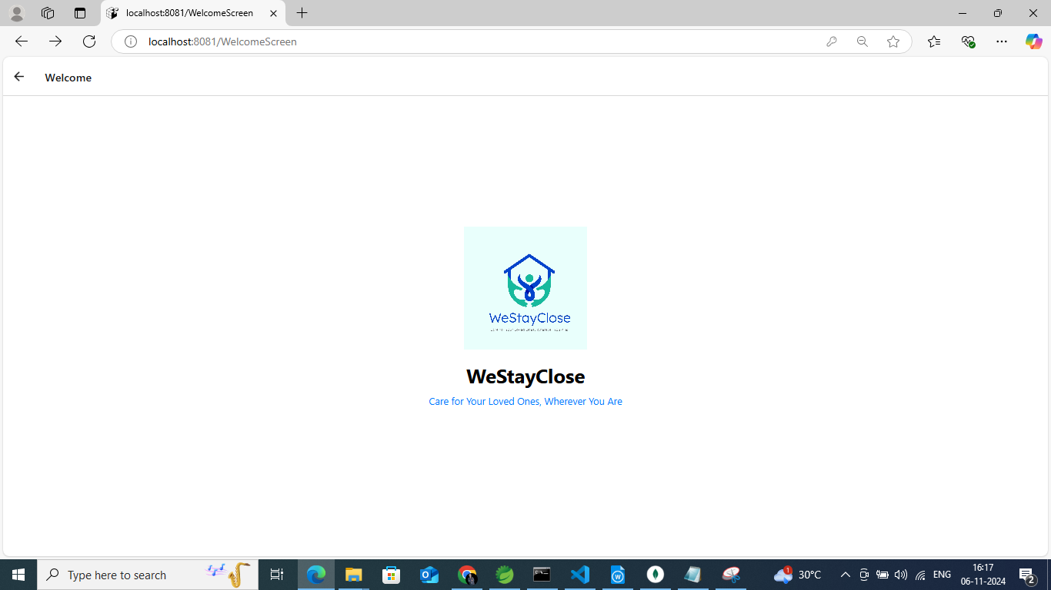

Description:

A user-friendly introduction screen that sets the tone for the application, featuring navigation options to log in or sign up.
Sign Up Screen:
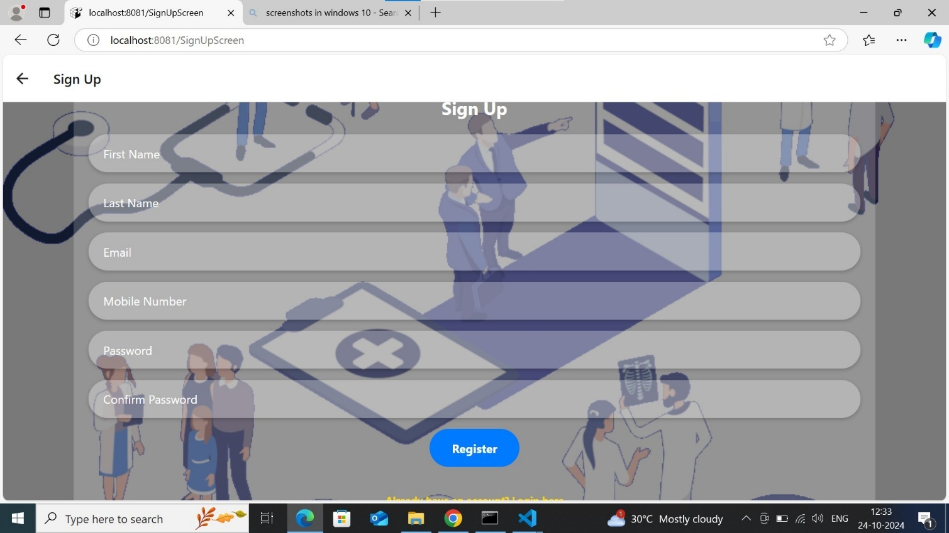

Description:
A registration page where new users can create an account by filling out their personal information and preferences.

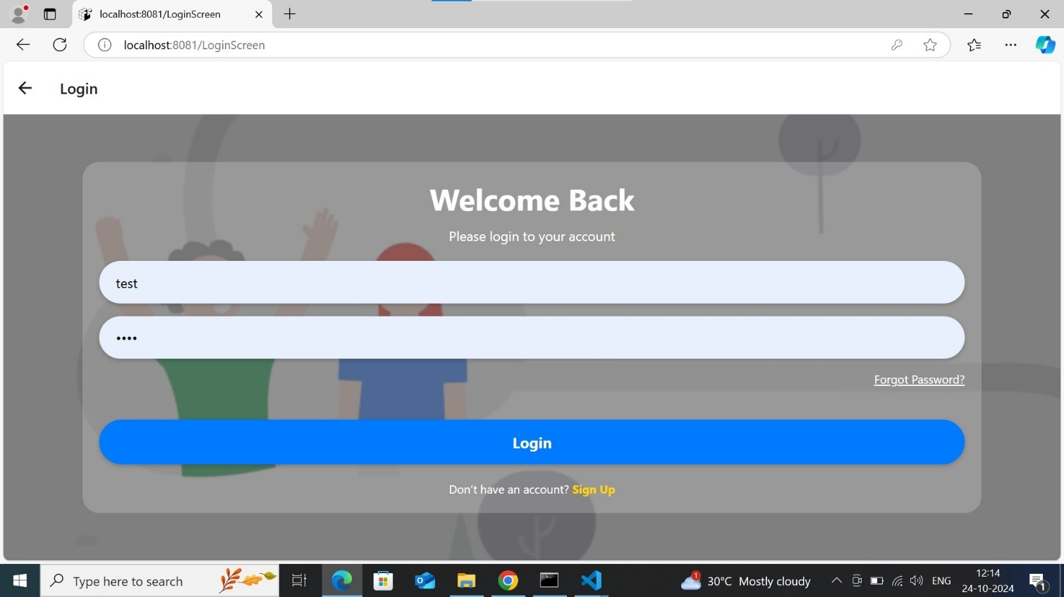
Login Screen:

Description:
A straightforward interface for users to enter their credentials and access their accounts securely.

Forgot Password:
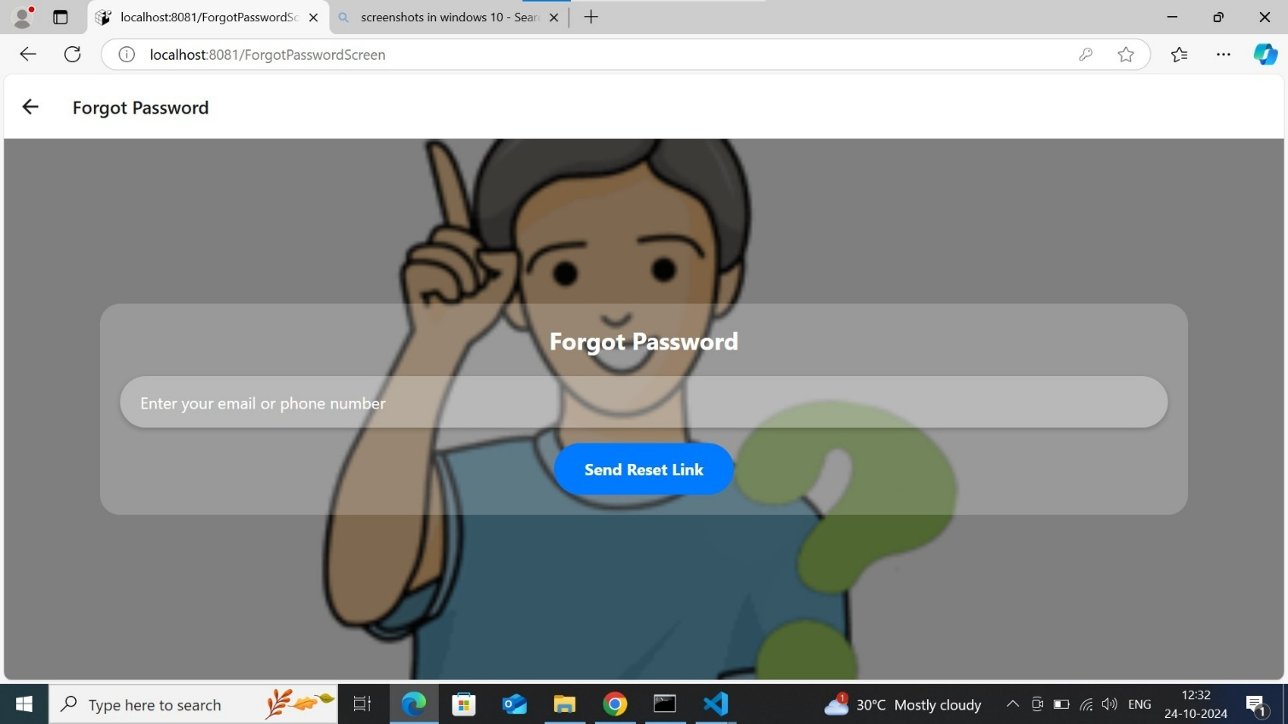

Description:

A secure page where users can initiate the password recovery process by entering their registered email or username.

Dashboard:
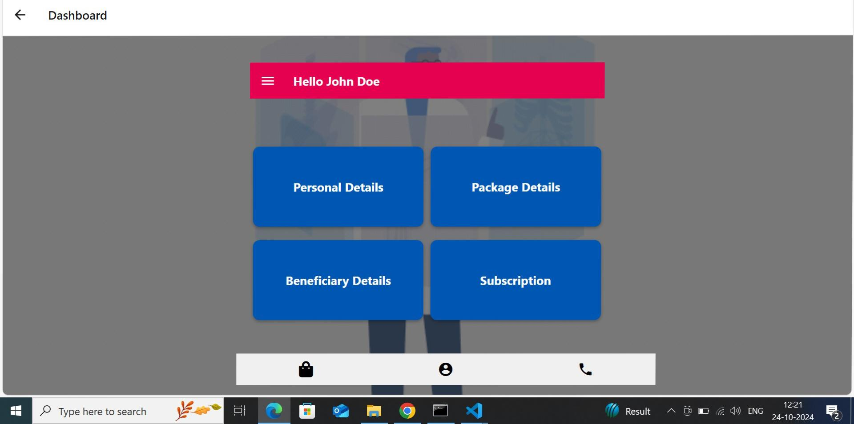

Description:

A central hub for users, showcasing key metrics, notifications, and quick access to essential functionalities.

CustomMenuScreen:

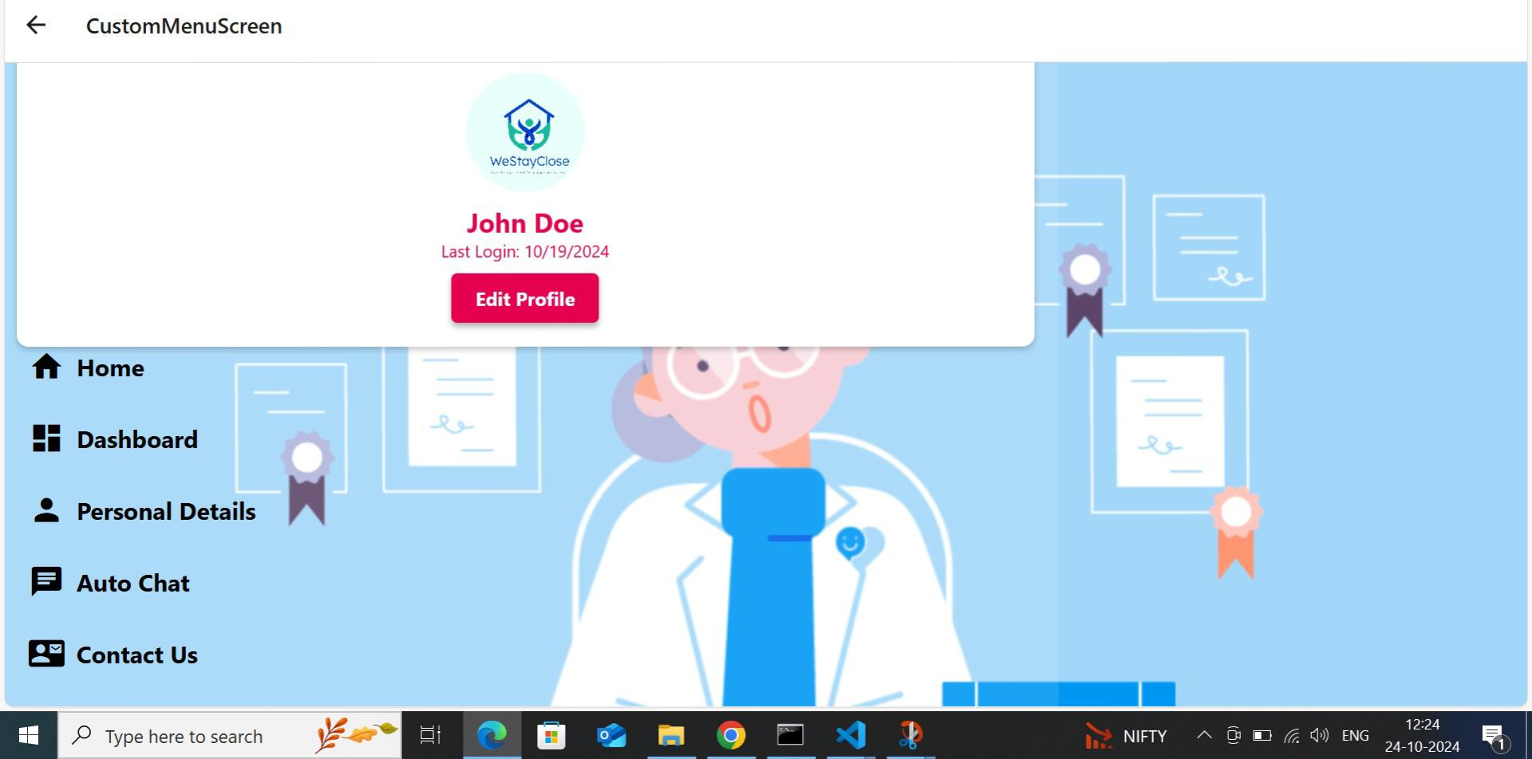

Description:

A personalized menu layout allowing users to access frequently used features and settings for easier navigation.

Beneficiary Details:
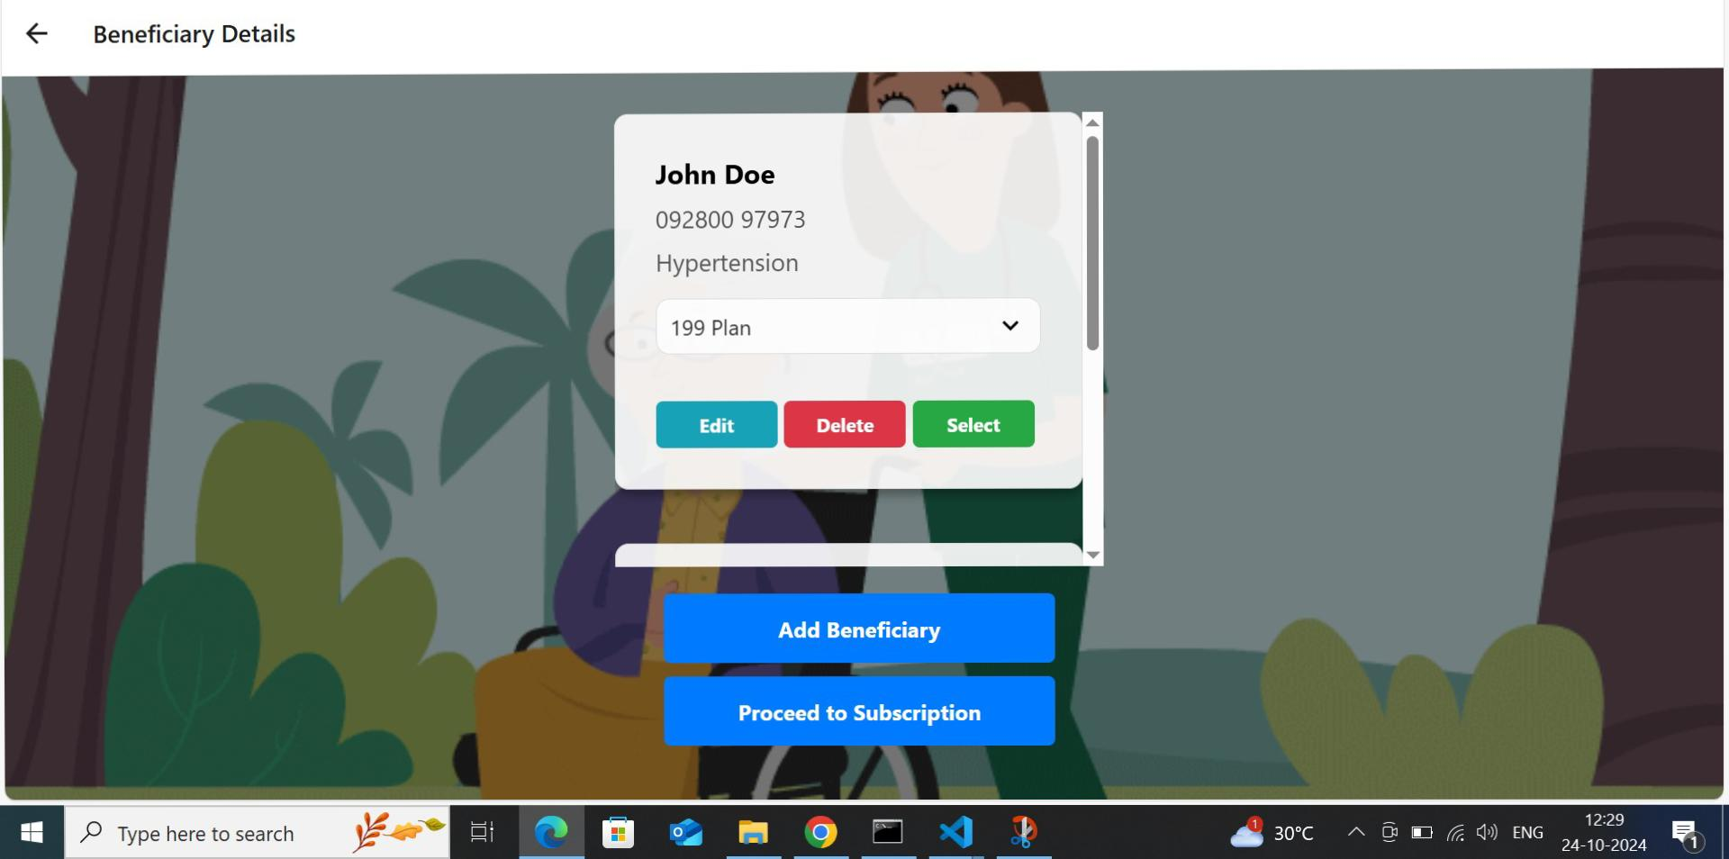

Description:

A section that displays comprehensive information about beneficiaries, including personal details and status updates.
Package Details:
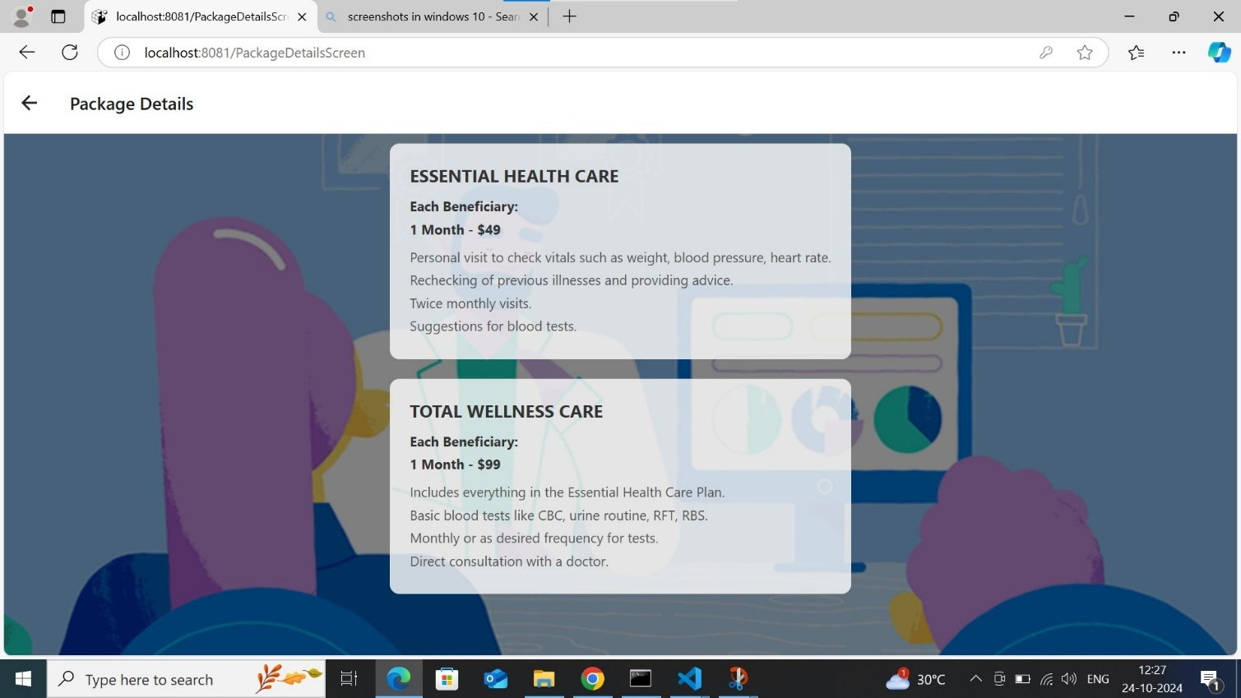
Description:
A detailed view of available packages, highlighting features, pricing, and benefits for informed decision-making.

Contact Us:
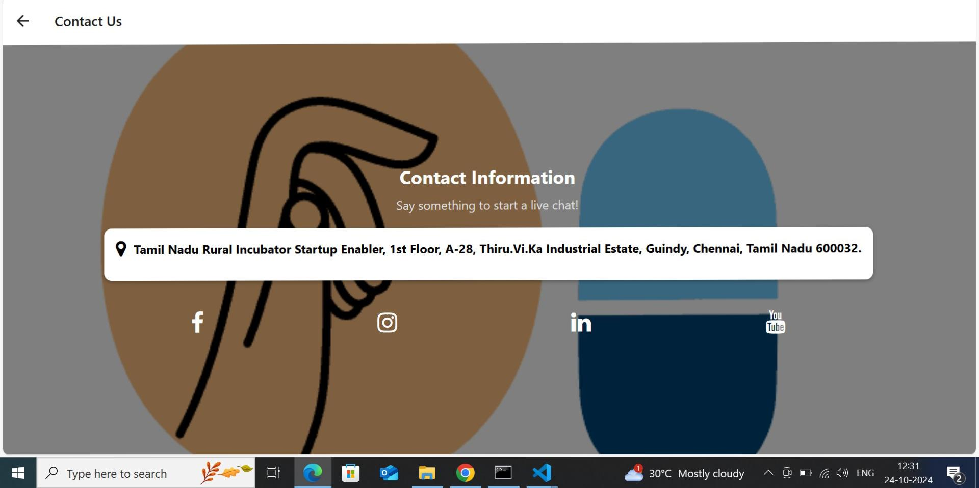

Description:

An interactive page providing users with various ways to reach support, including a form, phone number, and email.

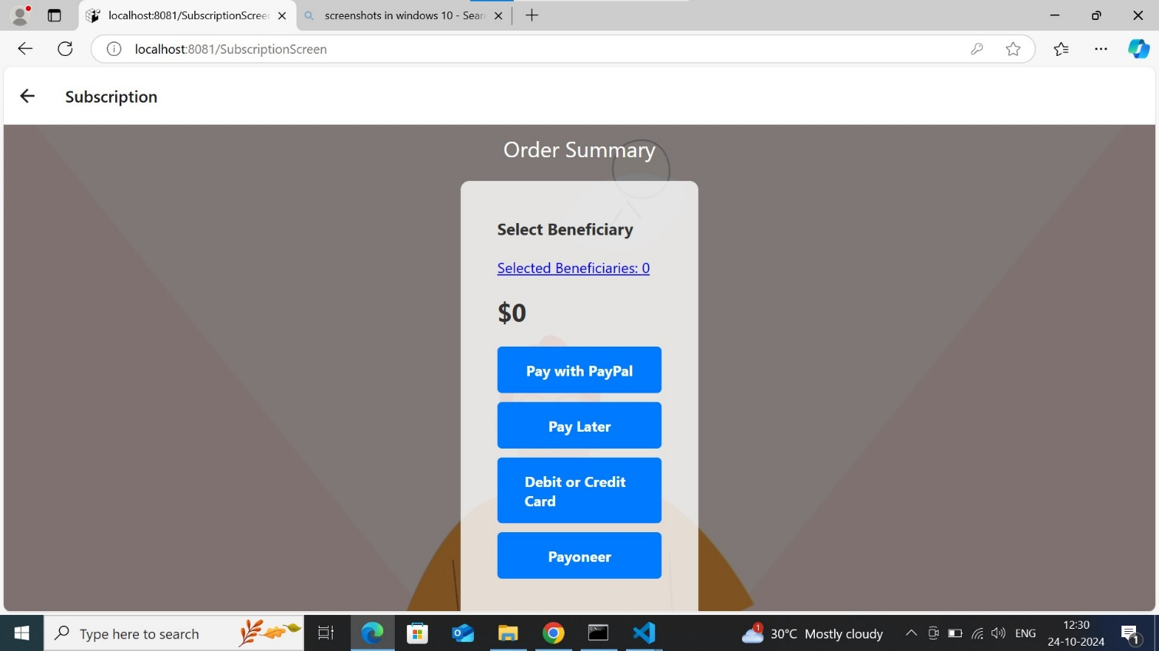
Subscription:

Description:

A section that allows users to manage their subscription plans, view renewal dates, and make changes as needed.

admin-login:

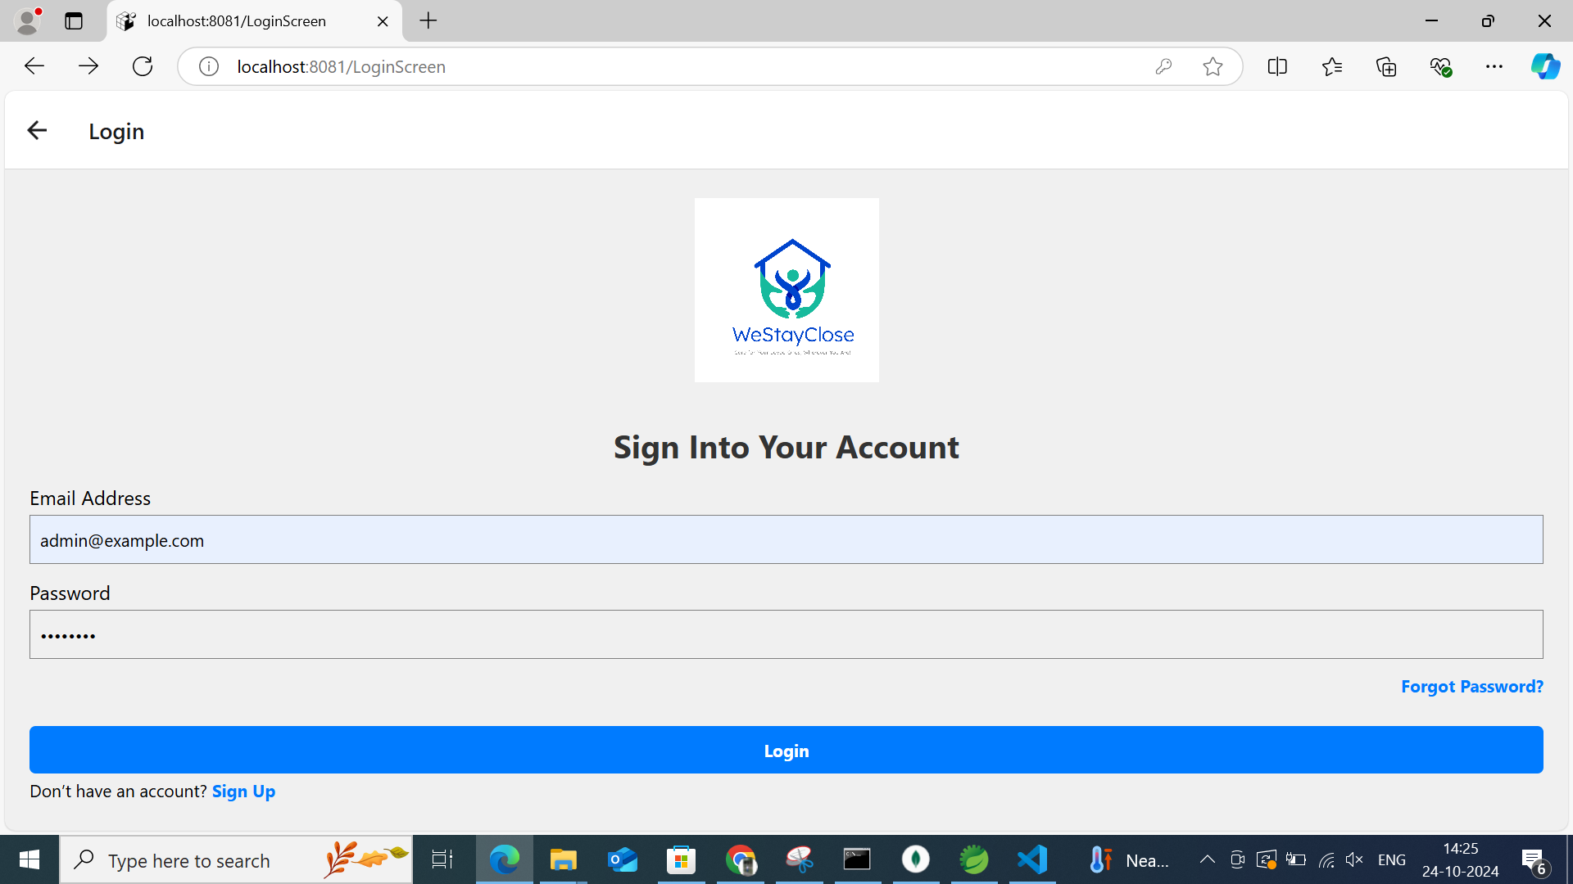
Description:
A secure entry point for administrators to access the backend management system of the application.

admin-dashbord:

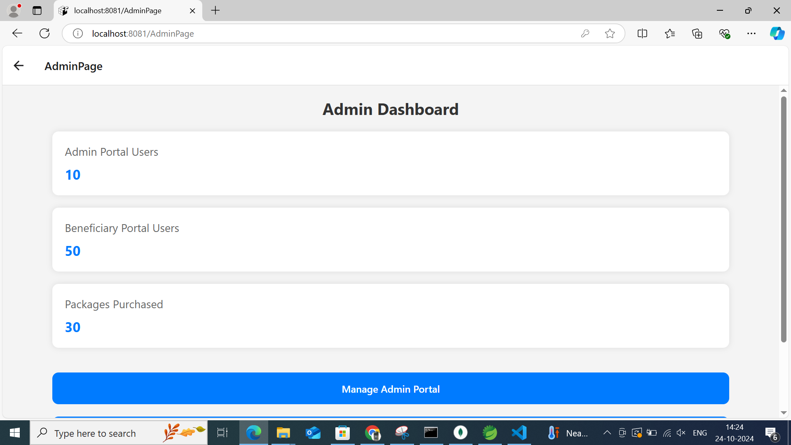
Description:

A comprehensive overview for admins, featuring analytics, user management tools, and system settings for effective oversight.

6. CONCLUSION AND FUTURE ENHANCEMENT

6.1. Conclusion
- Improved Efficiency: The system streamlines the management of healthcare beneficiaries, reducing administrative overhead and allowing healthcare providers to focus on patient care.
- Enhanced Accessibility: By centralizing beneficiary data, the system ensures that healthcare providers can quickly access essential information, leading to timely and informed decision-making.
- Data Security: Implementing robust security measures protects sensitive beneficiary information, ensuring compliance with healthcare regulations and maintaining patient confidentiality.
- User-Friendly Interface: The intuitive design of the system enhances user experience for both healthcare staff and beneficiaries, facilitating easier navigation and data entry.
- Scalability: The system is designed to adapt to the growing needs of healthcare organizations, allowing for the addition of new features and the integration of other systems as required.
- Informed Policy Decisions: The analytics capabilities of the system provide valuable insights into beneficiary demographics and healthcare trends, supporting data-driven policy-making and resource allocation.

6.2. Future Enhancement
The Healthcare Beneficiary Management System, we envision the integration of artificial intelligence to predict patient needs and optimize resource allocation. Additionally, incorporating telehealth features would enable remote consultations, increasing accessibility for beneficiaries. Expanding data analytics capabilities can provide deeper insights into patient demographics and treatment outcomes, guiding strategic decisions. Enhancing mobile access through a dedicated app would empower beneficiaries to manage their healthcare more effectively. Implementing blockchain technology could further improve data security and integrity, ensuring that beneficiary information is both secure and transparent. Lastly, fostering partnerships with other healthcare systems could facilitate seamless data sharing, enhancing overall patient care coordination.

BIBLIOGRAPHY

For JAVA:
• https://www.javatpoint.com/java-tutorial
• https://www.w3schools.com/java/
• https://www.geeksforgeeks.org/java/
For MONGODB:
• https://www.w3schools.com/mongodb/
• https://www.mongodb.com/

For REACT:
• https://docs.expo.dev/tutorial/introduction/
• https://reactnative.dev/docs/environment-setup

